THE ADITYA BIRLA PUBLIC SCHOOL VERAVAL



IP PROJECT ON RESTAURANT MANAGEMENT

PREPARED BY SUBMITTED TO

MASTER RUDRA BARAD MR. MUKESH KUMAR

rudra.barad@gmail.com H.O.D (Informatics Practices)

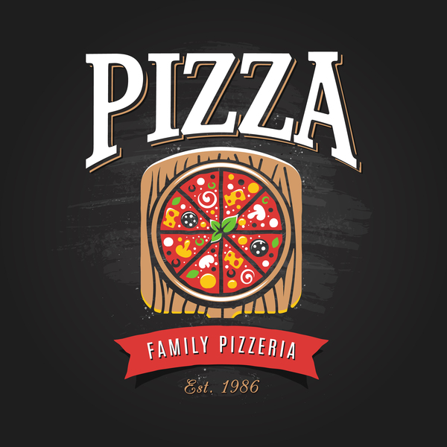



*THIS IS TO CERTIFY THAT* ***RUDRA BARAD*** *ROLL NO.* ***22*** *OF* ***CLASS XII-A*** *HAVING* ***AISCCE ROLL NO. 1100340*** *HAS COMPLETED HIS IP PROJECT**ON* ***RESTAURANT MANAGEMENT SYSTEM*** *DURING THE ACADEMIC YEAR* ***2017-2018*** *UNDER MY GUIDANCE. THE PROGRESS OF THE PROJECT HAS BEEN CONTINIOUSLY REPORTEDAND HAS BEEN IN MY KNOWLEDGE CONSISTENTLY.*

_______________ ________________ ________________

**TEACHER’S SIGN EXAMINER’S SIGN PRINCIPAL’S SIGN**

I FEEL PROUD TO PRESENT MY **IP PROJECT ON RESTAURANT MANAGEMENT SYSTEM**.

IT IS MYGREAT PLEASURE TO EXPRESS MY GRATITUDE TOWARDS MY TEACHER **Mr. MUKESH KUMAR SINGH** FOR HIS GUIDANCE, SUPPORT AND ENCOURAGEMENT THROUGHOUT THE PROJECT. WITHOUT HIS MOTIVATION AND HELP, THE SUCCESSFUL COMPLETION OF THIS PROJECT WOULD NOT HAVE POSSIBLE.

RIGOROUS HARD WORK HAS BEEN PUT IN THIS PROJECT TO ENSURE THAT IT PROVES TO BE THE BEST. I HOPE THAT THIS PROJECT WILL PROVE TO BE THEINSPIRATION FOR THE NEXT GENERATION OF STUDENTS AND WILL GUIDE THEM IN EVERY POSSIBLE WAY.

**OBJECTIVE**

* TO UPDATE CURRENT MANAGEMENT SYSTEMS
* TO KEEP REASTAURANT ORGANIZED
* TO SIMPLIFY AND MAKE IT EASIER TO MANAGE
* TO CONTROL EVERY RECORDS OF RESTAURANT
* TO MANAGE ALL THE STOCK
* TO CHECK OR VIEW EVERY DETAILS OF RESTAURANT

**TASK**

Design, Develop and Document a User-Friendly Database Application based on e-business with GUI Front-End using Programming& Database skills learnt during the Academic Session 2017-2018.

**HARDWARE & SOFTWARE USED**

* Net Beans IDE 8.1
* MySQL 5.7 Command Line Client

**PROGRAMMING LANGUAGE USED**

* Java
* MySQL

**TOOLS USED**

* Snipping Tool

**REFERENCE**

* NCERT Textbook Class 11
* NCERT Textbook Class 12
* <http://peperoni.com.sg/>
* [www.google.com](http://www.google.com)
* [www.youtube.com](http://www.youtube.com)



FEATURES AVAILABLE

* SAFE AND SECURE MANAGEMENT SYSTEM
* USER FRIENDLY
* OPTION FOR ONILINE ORDERS
* FREE HOME DELIVERY *

FRAMES INCLUDE

* WELCOME FRAME
* HOME FRAME
* ABOUT US FRAME
* CONTACT US FRAME
* LOGIN FRAME
* ADMIN FRAME
* STOCK MANAGEMENT FRAME
* ORDER FRAME
* FEEDBACK FRAME

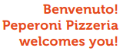

*Terms and Condition Applied

